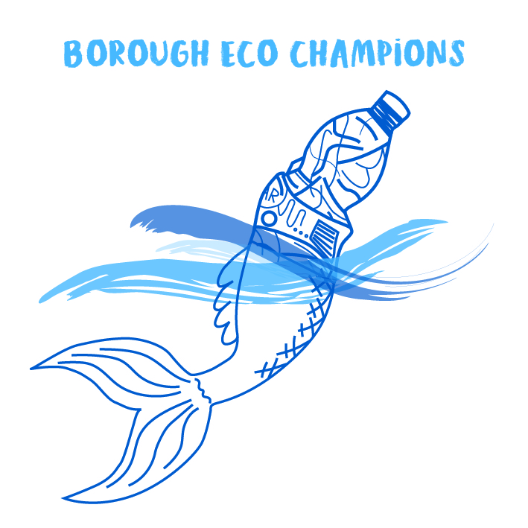
Scarborough Borough Council
Eco Champions- Reporting

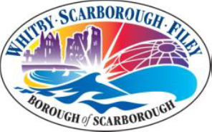

Name of School:

Level of accreditation working towards:
Please provide details of the activities your School has undertaken/ are currently working on as part of the Eco Champions Scheme. Please provide any photos or videos of your Eco Champions at work!

Please note that details of the Eco Champions Scheme and the work being undertaken by your students is published on the Scarborough Borough Council website. Therefore please ensure that your students comply with your school’s procedures in respect of publicity- photographs and video recordings prior to sending.

