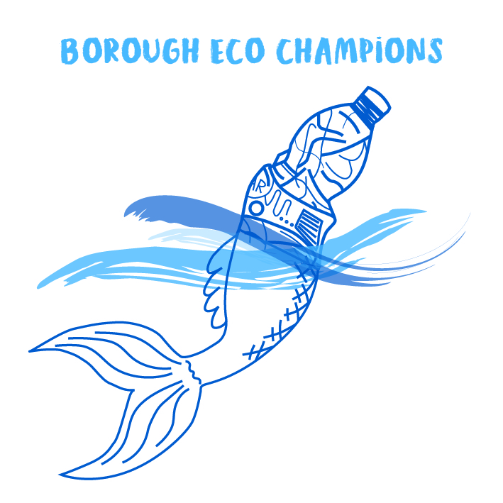
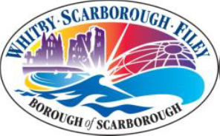

Scarborough Borough Council
Eco Champions- Year End Reporting

Name of School:

Level of accreditation working towards:
Please provide details of all of the activities your School has undertaken and completed as part of the Eco Champions Scheme. Please provide any project work, posters, photos or videos etc of your Eco Champions at work!

Please note that details of the Eco Champions Scheme, and the work being undertaken by your students, are published on the Scarborough Borough Council website. Therefore please ensure that your students comply with your school’s procedures in respect of publicity- photographs and video recordings prior to sending.
We would like to take this opportunity to thank you and your students for all of your hard work and dedication throughout the academic year. The Eco Champions Scheme is helping to make people more conscious of their environmental impact and your students are making great strides in encouraging all members of our community to engage in more environmentally friendly practices!

Feedback

We would be grateful of any feedback you can provide to us to help us improve the current Eco Champions Scheme.
Did your students enjoy taking part in the Eco Champions Scheme?
Yes No
Did aspects of the Eco Champions fit in with your curriculum?
Yes No
If Yes, which aspects?

Are there any aspects of the scheme which your students did not enjoy?
Yes No
If Yes, which aspects?

Are there any aspects of the scheme which you felt were unrealistic/ unobtainable?
Yes No
If Yes, which aspects?

Would you take part in the scheme again next year?
Yes No

